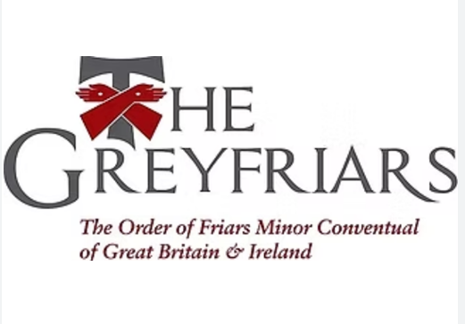
Safeguarding Children, Young People and Adults at Risk
Every human being has a value and dignity which we in the Church and as Franciscans of the Order of Friars Minor Conventual (Greyfriars) acknowledge as coming from God's creation of male and female in his own image and likeness. This implies a duty to value all people and to support them and protect them from harm.
The Greyfriars are committed to observe and implement the Safeguarding Policies of the Catholic Church in England, Wales, Scotland and Ireland in line with the standards, policies and procedures enunciated by Catholic Safeguarding Standards Agency (website: www.catholicsafeguarding.org.uk ; email: admin@catholicsafeguarding.org.uk) and the Irish National Board for Safeguarding Children in the Catholic Church in Ireland (website: www.safeguarding.ie ; email: admin@safeguarding.ie ) , believing that every child, young person and adult at risk has a right to expect the highest level of care, protection, love, encouragement and respect.
Reporting abuse
If you are concerned about the welfare of a child or adult at risk, do not delay in contacting the police, using 999 if a child or adult is believed to be in immediate danger.
It is the policy of the Catholic Church in England, Wales, Scotland and Ireland to report all allegations of abuse to statutory authorities, regardless of whether the abuse occurred recently or in the past, or whether the accused person is living or deceased.
If you are in any role (cleric, religious, staff or volunteer) within the Franciscan Order of Friars Minor Conventual in the UK and Ireland, you must refer allegations directly to those with responsibility for safeguarding within the Order of Friars Minor Conventual or directly to the civil authorities: Police and Social Services (UK) and Garda Siochana and Tulsa (Republic of Ireland).
If you are a member of the public, please refer allegations directly to the police (UK)/ Garda (Republic of Ireland) and also to the those with responsibility for safeguarding within the Order of Friars Minor Conventual in the UK and Ireland.
The Friars with Safeguarding responsibility are:
Fr Colin Mary Edwards OFM Conv, Our Lady of the Visitation Friary, Fairview Strand, Fairview Dublin Tel: 00353 1 837 6000;
Fr Maximilian Martin, St Anthony’s Friary, 1 Elmsley Road, Liverpool, L18 8AY Tel. 0151 724 2109
Email for Ireland: safeguarding.ireland@thegreyfriars.org
Email for the UK: safeguarding.uk@thegreyfriars.org
Statement review date: April 2026

